TO: MOTI LEVY WAKEnSURF 07-5599 2267
114 WHARF STREET
TWEED HEADS 2485

DATE: ________________

FROM:__________________________________________________

ADDRESS:______________________________________________

_____________________________________Postcode: ________

MOBILE: ____________________________ TEL: _____________________

NEED REPAIR ON:

BAR / LINE / HARNESS / BOARD
KITE MAKER: _____________ COLOR: _______________________
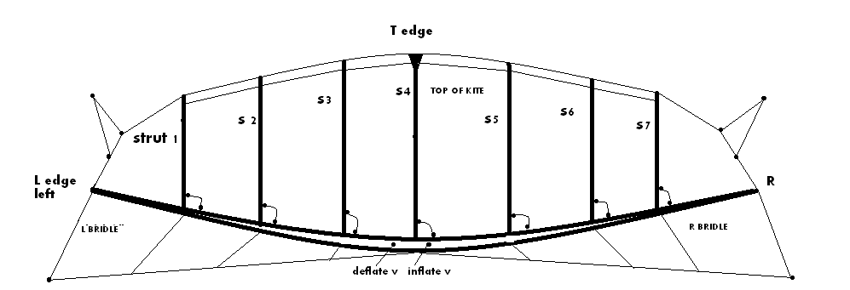

CANOPY L / C / R LEADING EDGE L / C / R. STRUT 1 / 2 / 3 / 4 / 5 / 6 / 7

KITE BLADDER – LEADING EDGE

SLOW LEAK / FAST LEAK / VALVE LEAK

OTHERS: …………………………………………………………………………………………….

…………………………………………………………………………………………………………….

……………………………………………………………………………………………………………

